Supplementary Figure S1
Stability of Central Indices for the IIP-32 Dimensions Tested Using Non-Parametric Bootstrapped Estimate.
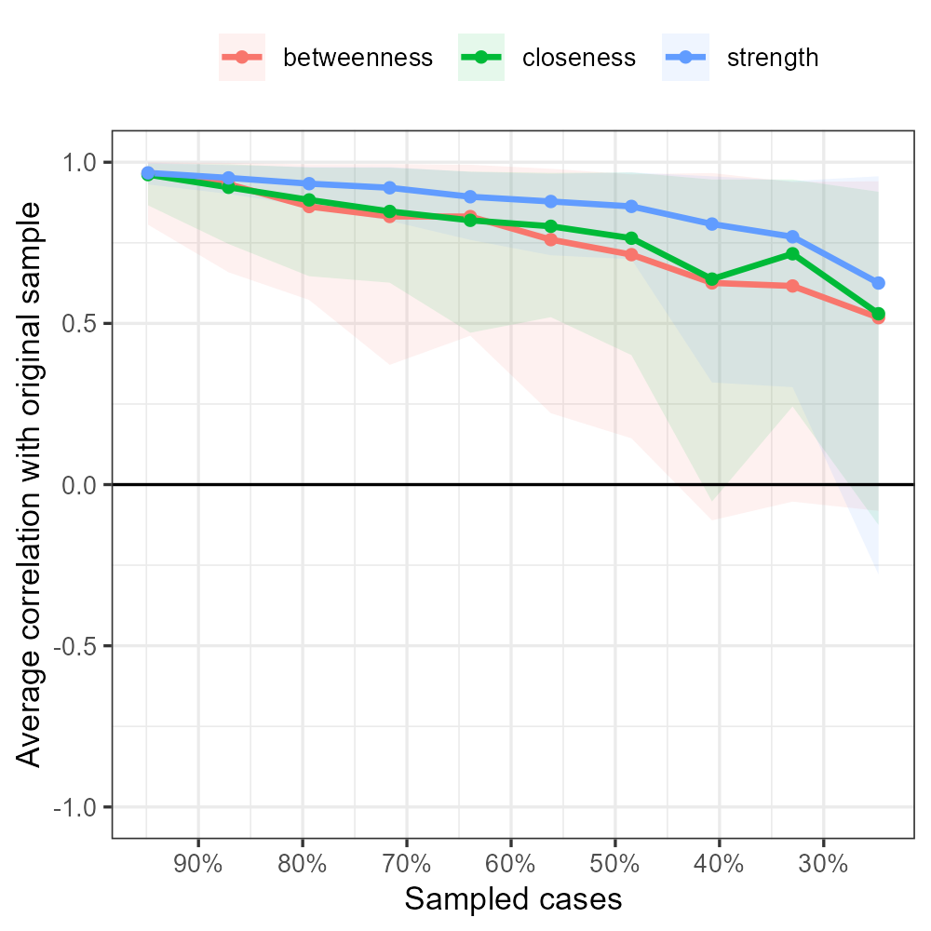

Note. The graph shows the average correlation between bootstrap centrality indices of networks sampled with node-dropping.

Supplementary Figure S2
Edge Stability Estimate for the IIP-32 Dimensions Tested Using Non-Parametric Bootstrapped Estimate.
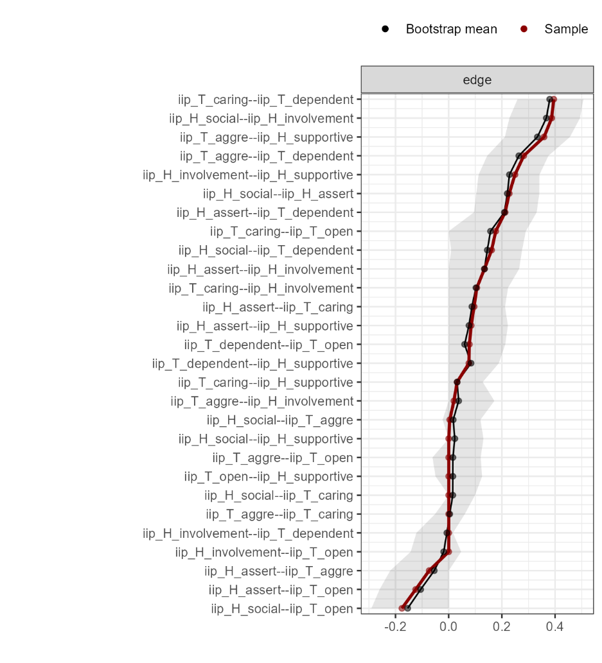
Note. The x-axis represents the edges, while every line on the y-axis represents a specific edge. The red line shows the estimate of the edge weights, and the gray bars the 95% confidence intervals for the estimates.

Supplementary Figure S3
Centrality Plots (Betweenness, Closeness, Degree, and Expected Influence) for Age, Gender and the IIP-32 and ODD Nodes in the Network Analysis 2.
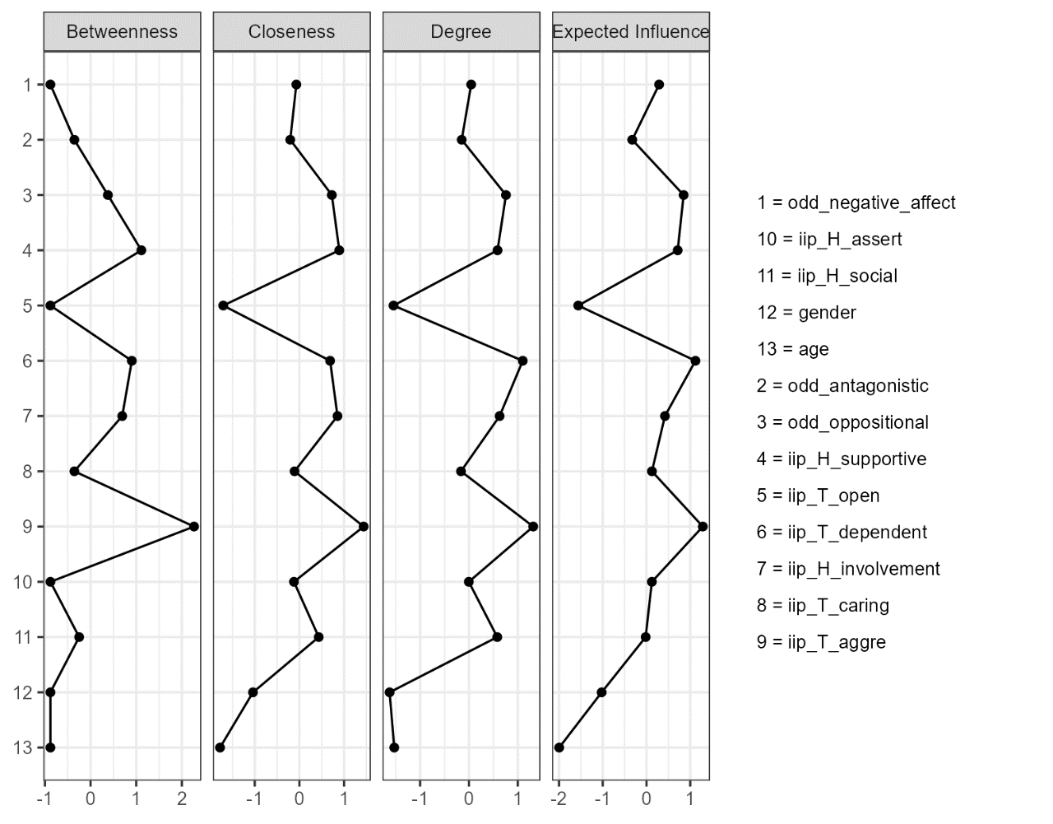
Note. Values shown on the x-axis are standardized z-scores.

Supplementary Figure S4
Stability of Central Indices for the Age, Gender, and the IIP-32 and ODD Dimensions Tested Using Non-Parametric Bootstrapped Estimate in Network Analysis Model 2.
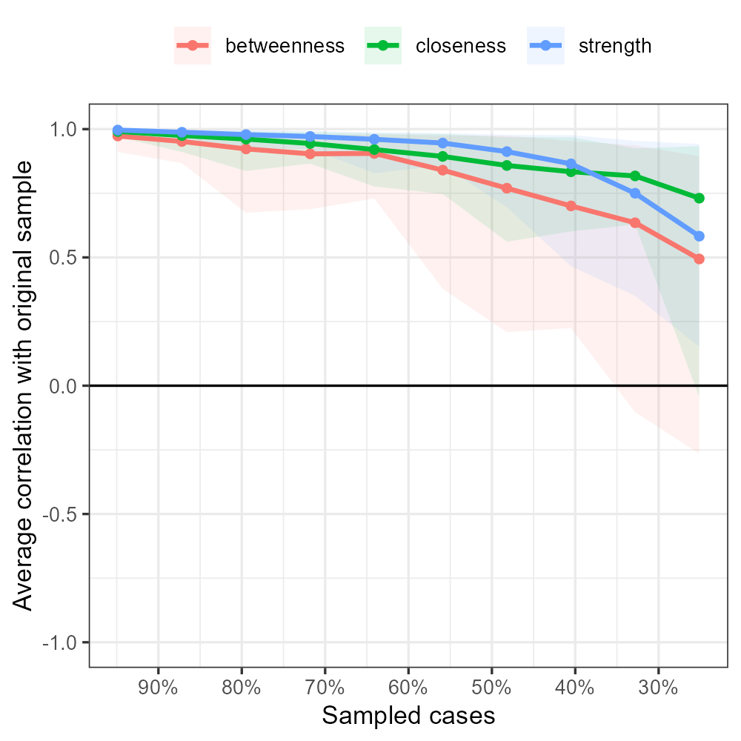

Note. The graph shows the average correlation between bootstrap centrality indices of networks sampled with node-dropping.

Supplementary Figure S5
Network Analysis of Age, Gender, ODD and IIP-32 Dimensions in Network Analysis Model 2.
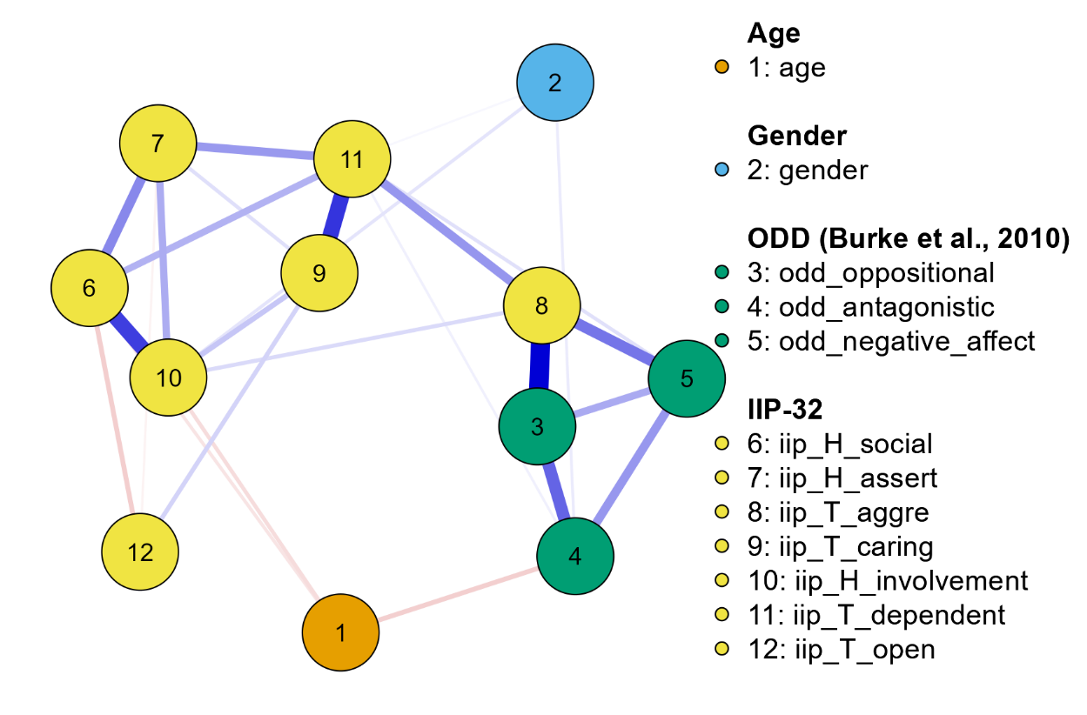

Supplementary Figure S6
Edge Stability Estimate for Age, Gender, and the IIP-32 and ODD Dimensions Tested Using Non-Parametric Bootstrapped Estimate in Network Analysis Model 2
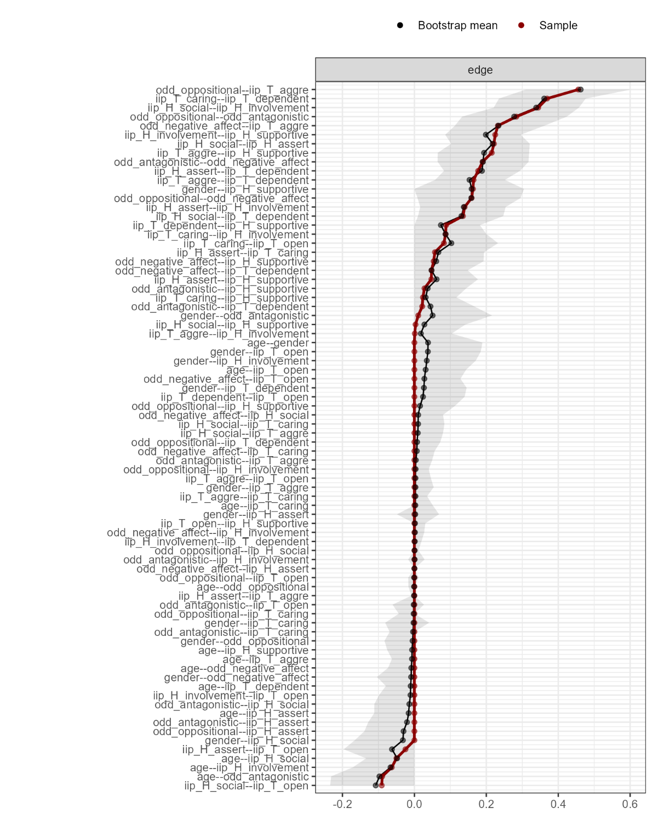
Note. The x-axis represents the edges, while every line on the y-axis represents a specific edge. The red line shows the estimate of the edge weights, and the grey bars the 95% confidence intervals for the estimates.

