Supplementary Information

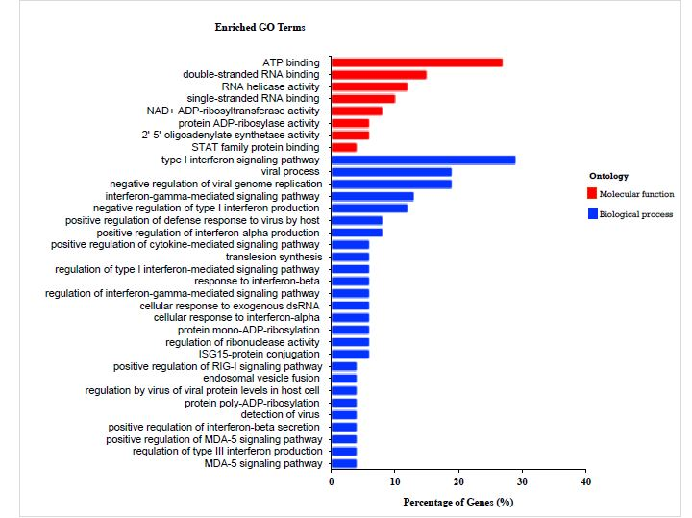

Figure S1: Functional enrichment analysis. Red bars are the enriched molecular function terms (p<0.05), whereas the blue bars are the enriched biological processes. Gene Ontology enrichment analysis (http://geneontology.org) was conducted to identify the relative biological process.

Table S1: The concentration and purity of the total RNA of each sample were assessed by NanoDrop 200 and Agilent 2200 TapeStation system.
Nanodrop 2000 |  |  |  |  |  |  | Bioanalyzer
No | Sample | Volume (µl) | RNA | RNA |  |  |  | Grade
 |  |  | concentration (ng/µl) | quality (µg) | A260/280 | A260/230 | RIN value
1 | MC 1 | 15 | 387.4 | 5.81 | 1.95 | 1.19 | 10 | A
2 | MC 2 | 15 | 391 | 5.86 | 1.94 | 1.68 | 10 | A
3 | MC 3 | 15 | 388.9 | 5.83 | 1.94 | 1.68 | 10 | A
4 | MT 1 | 15 | 373.2 | 5.6 | 1.92 | 1.96 | 10 | A
5 | MT 2 | 15 | 387.1 | 5.81 | 1.94 | 1.9 | 10 | A
6 | MT 3 | 15 | 333.1 | 5 | 1.92 | 1.92 | 10 | A
MC=Melanoma (Control); MT=Melanoma (Treatment); Grade A indicates that RNA has a high level quality.

Table S2: Summary statistics of raw data (before preprocessing) of each sample.

Samples | Read Length (bp) | Number of Reads | Bases | Q20 (%) | Q30 (%) | GC (%) | N  (ppm)
MC1 | 150 | 44779718 | 6716957700 | 97.19 | 92.54 | 48.94 | 5.43
MC2 | 150 | 53415256 | 8012288400 | 96.29 | 90.67 | 48.05 | 6.74
MC3 | 150 | 40011192 | 6001678800 | 96.85 | 91.87 | 48.14 | 5.08
MT1 | 150 | 44349902 | 6652485300 | 96.57 | 91.28 | 48.43 | 5.45
MT2 | 150 | 44663832 | 6699574800 | 96.58 | 91.38 | 48.94 | 5.26
MT3 | 150 | 50002812 | 7500421800 | 96.82 | 91.86 | 48.98 | 5.28

Table S3: Summary statistics of the mapped reads.

Samples | Number of reads | Number of mapped reads | Number of Multiple mapped reads | Number of Uniquely mapped reads
MC1 | 44650030 | 40037265  (89.7%) | 2295113 (5.1%) | 37742152 (84.5%)
MC2 | 53267710 | 48000640  (90.1%) | 2943532 (5.5%) | 45057108 (84.6%)
MC3 | 39896884 | 35828615  (89.8%) | 2052265 (5.1%) | 33776350 (84.6%)
MT1 | 44223910 | 39487265  (89.3%) | 2115444 (4.8%) | 37371821 (84.5%)
MT2 | 44486072 | 39642404  (89.1%) | 2231295 (5.0%) | 37411109 (84.1%)
MT3 | 49861882 | 44583036  (89.4%) | 2486721 (4.9%) | 42096315 (84.4%)

Table S4: Summary of differential expression genes with the cutoff of fold change ≥ 1.5.
Gene ID | Fold | Gene | MC vs | Gene description
 | Change | symbol | MT
ENSG00000111335 | 16.73 | OAS2 | up | 2'-5'-oligoadenylate synthase 2 OAS2
ENSG00000137959 | 15.62 | IFI44L | up | Interferon-induced protein 44-like IFI44L
ENSG00000126709 | 13.61 | IFI6 | up | Interferon alpha-inducible protein 6 IFI6
ENSG00000185745 | 11.69 | IFIT1 | up | Interferon-induced protein with tetratricopeptide repeats 1 IFIT1
ENSG00000204375 | 10.24 | XAGE1E | up | X antigen family, member 1E
ENSG00000165949 | 8.98 | IFI27 | up | Interferon alpha-inducible protein 27, mitochondrial IFI27
ENSG00000089127 | 7.67 | OAS1 | up | 2'-5'-oligoadenylate synthase 1 OAS1
ENSG00000133106 | 5.77 | EPSTI1 | up | Epithelial-stromal interaction protein 1 EPSTI1
ENSG00000187608 | 3.31 | ISG15 | up | Ubiquitin-like protein ISG15 ISG15
ENSG00000130589 | 3.15 | HELZ2 | up | Helicase with zinc finger domain 2HELZ2
ENSG00000111331 | 3.06 | OAS3 | up | 2'-5'-oligoadenylate synthase 3 OAS3
ENSG00000138496 | 3.03 | PARP9 | up | Poly [ADP-ribose] polymerase 9 PARP9
ENSG00000184979 | 3.02 | USP18 | up | Ubl carboxyl-terminal hydrolase 18 USP18
ENSG00000138642 | 2.91 | HERC6 | up | Probable E3 ubiquitin-protein ligase HERC6 HERC6
ENSG00000137628 | 2.77 | DDX60 | up | Probable ATP-dependent RNA helicase DDX60 DDX60
ENSG00000115267 | 2.63 | IFIH1 | up | Interferon-induced helicase C domain-containing protein 1 IFIH1
ENSG00000177409 | 2.63 | SAMD9L | up | Sterile alpha motif domain-containing protein 9-like SAMD9L
ENSG00000134326 | 2.53 | CMPK2 | up | UMP-CMP kinase 2, mitochondrial CMPK2
ENSG00000100918 | 2.5 | REC8 | up | Meiotic recombination protein REC8 homolog REC8
ENSG00000108771 | 2.5 | DHX58 | up | Probable ATP-dependent RNA helicase DHX58 DHX58
ENSG00000213928 | 2.41 | IRF9 | up | Interferon regulatory factor 9 IRF9
ENSG00000119917 | 2.38 | IFIT3 | up | Interferon-induced protein with tetratricopeptide repeats 3 IFIT3
ENSG00000259529 | 2.38 | RP11- 468E2.4 | up | E3 ubiquitin-protein ligase RNF31
ENSG00000137965 | 2.36 | IFI44 | up | Interferon-induced protein 44 IFI44
ENSG00000101347 | 2.19 | SAMHD1 | up | Deoxynucleoside triphosphate triphosphohydrolase SAMHD1 SAMHD1
ENSG00000173193 | 2.14 | PARP14 | up | Poly [ADP-ribose] polymerase 14 PARP14
ENSG00000059378 | 2.12 | PARP12 | up | Poly [ADP-ribose] polymerase 12 PARP12
ENSG00000185507 | 2.11 | IRF7 | up | Interferon regulatory factor 7 IRF7
ENSG00000115415 | 2.11 | STAT1 | up | Signal transducer and activator of transcription 1-alpha/beta STAT1
ENSG00000188313 | 2.04 | PLSCR1 | up | Phospholipid scramblase 1 PLSCR1
ENSG00000251196 | 2.01 | AC106760. 1 | up | Novel pseudogene
ENSG00000163840 | 1.89 | DTX3L | up | E3 ubiquitin-protein ligase DTX3L - DTX3L
ENSG00000068079 | 1.87 | IFI35 | up | Interferon-induced 35 kDa protein - IFI35
ENSG00000099834 | 1.86 | CDHR5 | up | Cadherin-related family member 5 - CDHR5
ENSG00000205413 | 1.83 | SAMD9 | up | Sterile alpha motif domain-containing protein 9 - SAMD9
ENSG00000055332 | 1.81 | EIF2AK2 | up | Interferon-induced, double-stranded RNA-activated protein kinase - EIF2AK2
ENSG00000178685 | 1.79 | PARP10 | up | Poly [ADP-ribose] polymerase 10 - PARP10
ENSG00000131471 | 1.77 | AOC3 | up | Membrane primary amine oxidase - AOC3
ENSG00000168016 | 1.76 | TRANK1 | up | TPR and ankyrin repeat-containing protein 1 - TRANK1
ENSG00000107201 | 1.7 | DDX58 | up | Probable ATP-dependent RNA helicase DDX58 - DDX58
ENSG00000181381 | 1.67 | DDX60L | up | Probable ATP-dependent RNA helicase DDX60-like - DDX60L
ENSG00000117228 | 1.66 | GBP1 | up | Guanylate-binding protein 1 - GBP1
 |  |  |  | Transmembrane protein with metallophosphoesterase domain -
ENSG00000188167 | 1.65 | TMPPE | up | TMPPE
ENSG00000183458 | 1.65 | RP11- 958N24.1 | up | Uncharacterized protein (Fragment) unassigned
ENSG00000135899 | 1.63 | SP110 | up | Sp110 nuclear body protein - SP110
ENSG00000106785 | 1.6 | TRIM14 | up | Tripartite motif-containing protein 14 - TRIM14
ENSG00000119922 | 1.59 | IFIT2 | up | Interferon-induced protein with tetratricopeptide repeats 2 - IFIT2
ENSG00000272933 | 1.58 | AL391121.1 | up | Novel transcript
ENSG00000142089 | 1.57 | IFITM3 | up | Interferon-induced transmembrane protein 3 - IFITM3
ENSG00000130813 | 1.56 | SHFL | up | Repressor of yield of DENV protein - RYDEN
ENSG00000233101 | 1.55 | HOXB-AS3 | up | HOXB cluster antisense RNA 3
ENSG00000182179 | 1.54 | UBA7 | up | Ubiquitin-like modifier-activating enzyme 7 - UBA7
ENSG00000152778 | 1.53 | IFIT5 | up | Interferon-induced protein with tetratricopeptide repeats 5 - IFIT5
ENSG00000156587 | 1.53 | UBE2L6 | up | Ubiquitin/ISG15-conjugating enzyme E2 L6 - UBE2L6
ENSG00000196683 | -1.55 | TOMM7 | down | Mitochondrial import receptor subunit TOM7 homolog-TOMM7
ENSG00000212802 | -1.57 | RPL15P3 | down | ribosomal protein L15 pseudogene 3
ENSG00000242071 | -1.6 | RPL7AP6 | down | ribosomal protein L7a pseudogene 6
ENSG00000243449 | -1.64 | C4orf48 | down | chromosome 4 open reading frame 48
ENSG00000172428 | -1.65 | MYEOV2 | down | myeloma overexpressed 2
ENSG00000213866 | -1.7 | YBX1P10 | down | Y box binding protein 1 pseudogene 10
ENSG00000184779 | -1.79 | RPS17 | down | ribosomal protein S17
ENSG00000233328 | -1.83 | PFN1P1 | down | profilin 1 pseudogene 1
ENSG00000223803 | -1.87 | RPS20P14 | down | ribosomal protein S20 pseudogene 14
 |  | AC092718. |  | Novel transcript
ENSG00000261061 | -1.99 | 4 | down
 |  | AC122718. |  | family with sequence similarity 133, member B (FAM133B)
ENSG00000250461 | -2 | 1 | down | pseudogene
ENSG00000218175 | -2.01 | AC016739. 1 | down | ribosomal protein, large, P1 (RPLP1) pseudogene
ENSG00000234009 | -2.2 | RPL5P34 | down | ribosomal protein L5 pseudogene 34
ENSG00000237550 | -11.98 | UBE2Q2P6 | down | ubiquitin-conjugating enzyme E2Q family member 2 pseudogene 6

