Supplementary Materials

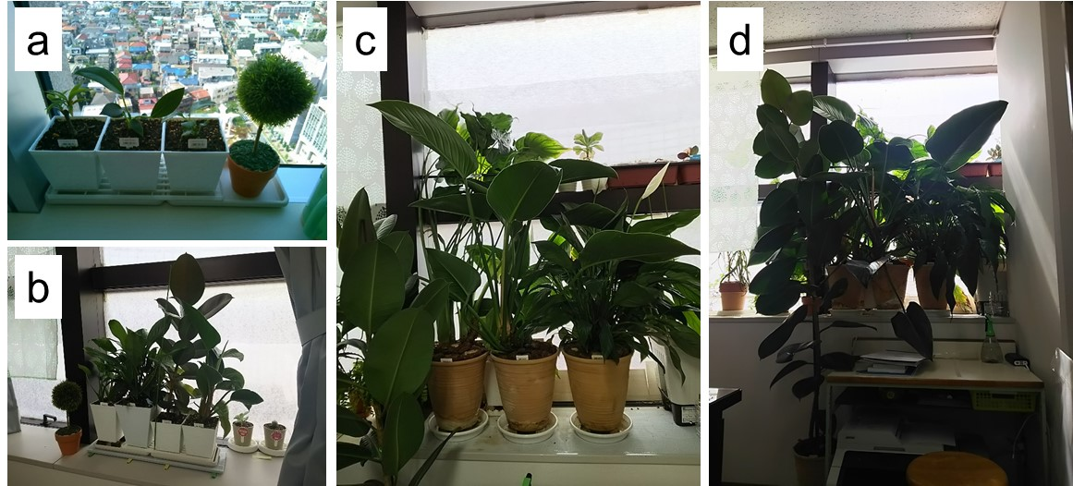
Supplementary Fig. 1 Cultivation of ornamental foliage plants. a) June 2015, b) March 2018, c) April 2019, d) April 2020.

